*Short description about the application that you like to build*

I would like to create a game/ tournament manager. One of my previous classes involved me writing a similar program in Java. At that point, I was not really good at programming and so I did not do so well. The tracker will allow team members to be put into teams, actual physical teams to be created, create a game, load a game, view a game, and a screen that will declare on who is the winner.

*Short description of the business value that your application will provide. i.e. what's the problem that your application is solving.*

Gaming is today, tomorrow, and the future. I am not a video gamer at all and I really have no experience in that background. So, I wanted to create something that I know people could use and something I could actually construct. The problem that this application solves is that it allows individuals to control who is on their team, what team they are in, and more so the logistics of the game (rather than the game itself). This application is for users who want to play multiplayer games and be able to interact with their team members.

*Using any diagramming tool to diagram out the high-level flow of your application. You do not need to go into the detailed transaction level at this point. You just need to diagram the high-level interaction with the user/process and the main components within your application. Apply any diagramming experience that you had in the past (UML, BPMN, Flowchart, etc)*

Here is my uml diagram:

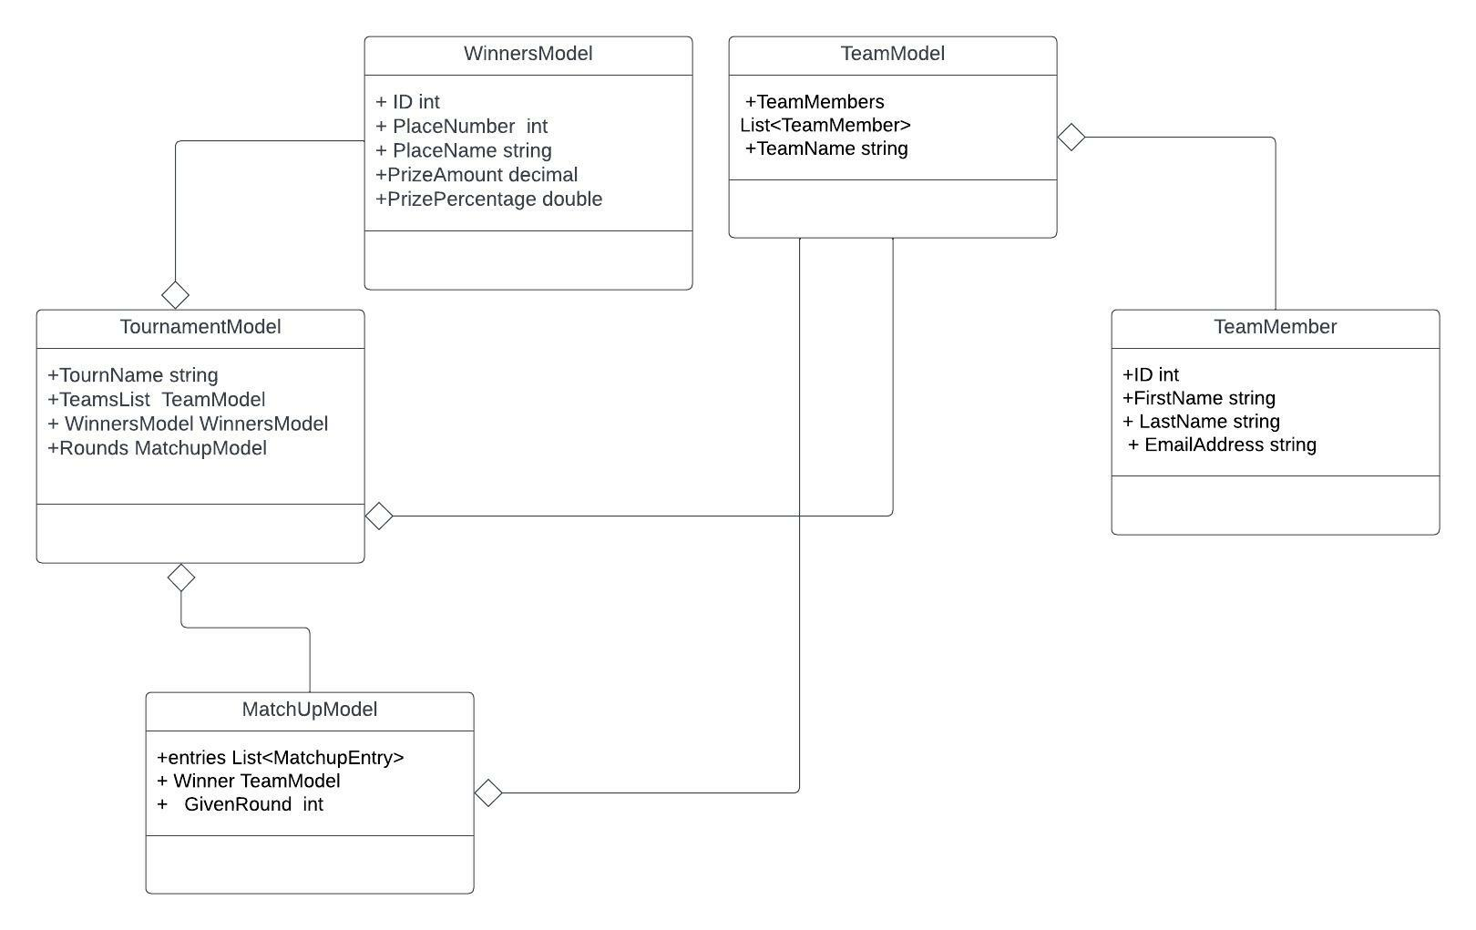

*Short description of the data that you'll collect and process with your application. You don't need to do any database and table design at this point.*

I will basically be filling out the different webpages/forms and having it store my responses in a textfile/csv file. This way data will be stored and processed. For example, I have a Team Member form. I will run the application, fill out all the different fields, click Ok, and that will automatically save in some sort of file.

*Provide an estimate on how many hours of work will take you to code this application. Just a guesstimate at this point.*

With my part-time job and full load schedule of class, I would like to spend no more than 2-3 hours per week on this project.